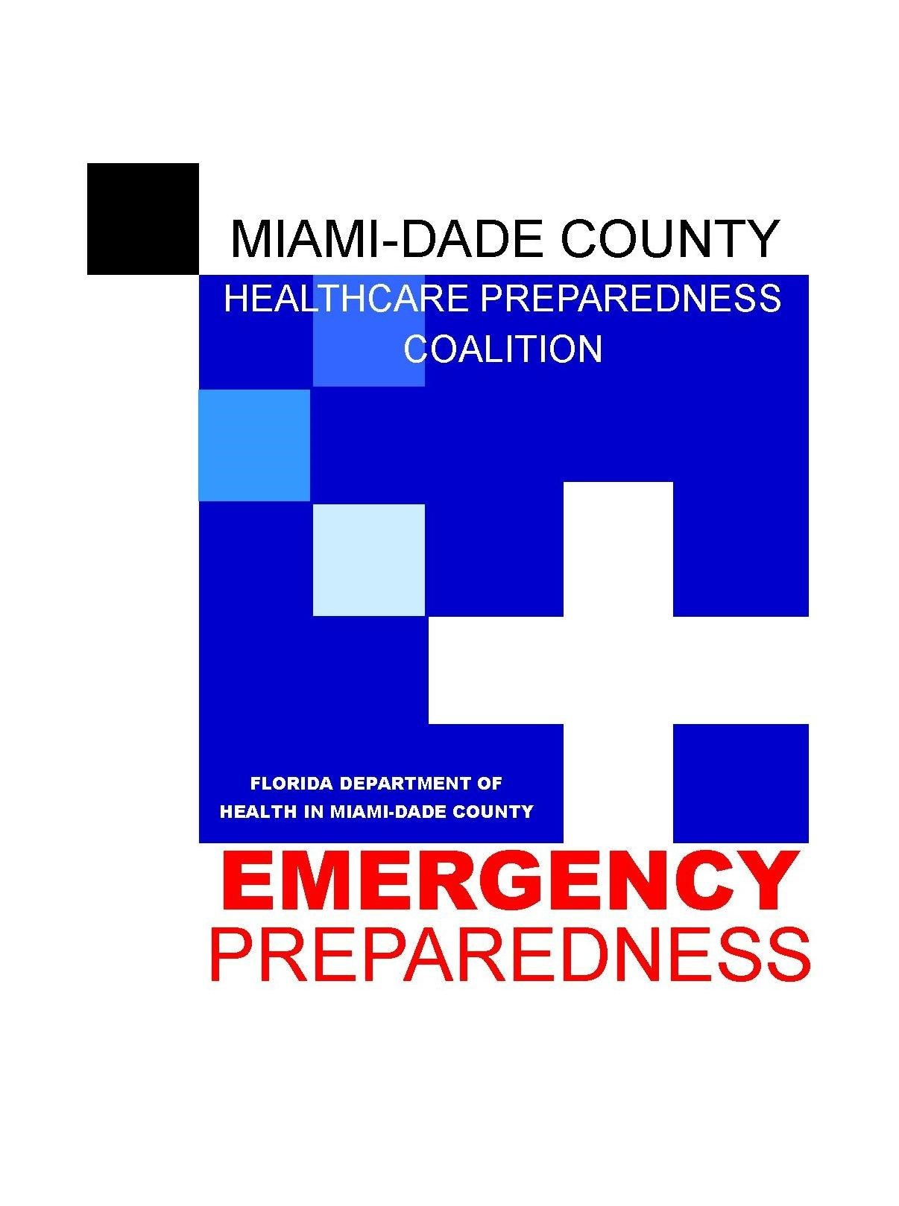
Members

Baptist Health South Florida

City of Miami Fire Rescue

Community Health of South Florida

Coral Gables Hospital

Elder Affairs

Encompass Health

Florida Department of Health in Miami-Dade County

Florida Health Care Association (FHCA)

Hialeah Hospital

Jackson Health System

Kendall Regional Medical Center

Kindred Hospital

Larkin Community Hospital

Larkin Community Hospital – Palm Springs Campus

Leon Medical Centers

Mactown, Inc

Mercy Hospital

Miami Beach Community Health Center

Miami Cerebral Palsy Residential Services

Miami Jewish Health Systems

Miami Veteran’s Affairs Health System

Miami-Dade Fire Rescue

Miami-Dade County Medical Association

Miami-Dade County Office of Medical Examiner

Miami-Dade County Office of Emergency Management

Miami-Dade Police Department

Mount Sinai Medical Center

Nicklaus Children’s Hospital

Palmetto General Hospital

RDSTF

University of Miami UHealth

Westchester Hospital

Funded by

Assistant Secretary for Preparedness & Response (ASPR)

Members

American Medical Response

American Red Cross

Bethesda Health

Boca Raton Regional Hospital

Delray Medical Center

Florida Health in PBC

Good Samaritan Medical Center

Health Care District of PBC

JFK Medical Center

Jupiter Medical Center

Kindred Healthcare

Lakeside Medical Center

NuVista Living

MorseLife

Palm Beach County Association of EMS Providers

PBC Division of Emergency Management

PBC Fire Rescue

PBC Medical Society Services

PBC Sheriff Office

Palm Beach Gardens Medical Center

Palms West Hospital

Select Specialty Hospital

St. Mary’s Medical Center

VA Medical Center

Wellington Regional Medical Center

West Boca Medical Center

West Palm Hospital

Funded by

Assistant Secretary for Preparedness & Response (ASPR)

Vendor Sponsorship Form
For MDCHPC Meeting
(Updated: 7/15/19)

MDCHPC MISSION: Our Mission is to protect the health and well-being of Miami-Dade County’s population through a continuous cycle of planning, preparedness, and mitigation to effectively facilitate an improved response to all-hazards events.

For additional information on MDCHPC go to: https://www.mdchpc.org/

$500 vendor sponsorship includes:
- Attendance at a MDCHPC General Membership meeting OR committee meeting;
- Ten to Fifteen (10-15) minute presentation on your product or service at meeting;
- Table to display products and services;
- Listing in monthly meeting notices to members;
- Networking opportunity pre and post meeting.

I would like to be a sponsor for
☐ General Membership meeting of the MDCHPC
☐ __________________ Committee Meeting of the MDCHPC

Preferred date* to sponsor _______________

Company Name______________________________
Contact Person________________________________
Address______________________________________
City_________________________ State__________ Zip _____
Phone____________ Fax
E-Mail________________________
Required authorized signature: ____________________________

PAYMENT METHOD:
__ Check enclosed (made payable to Miami-Dade County Healthcare Preparedness Coalition).

Please send completed form and check:
Email – marilia.vankeeken@smrt7.onmicrosoft.com
Miami-Dade County HPC
2681 SW 154 Lane, Davie, Fl 33331

